

Year 9 Science
Physics 2 Test: Light and Sound

SECTION 1: MULTIPLE CHOICE (1 mark each)
Circle your answer on the multiple choice answer sheet.

- Packets of light are called _________
  - Colours
  - Waves
  - Photons
  - Atoms

- Which of the following is not a type of energy?
  - Light
  - Sound
  - Heat
  - Colour

- Light intensity is measured in __________
  - Joules
  - Lumens
  - Watts
  - Hertz

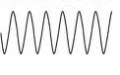
- Which of the following diagrams does not show a transverse wave?
a) b)
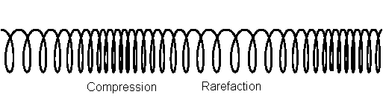


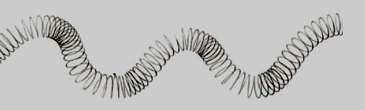
c) d)

- An object that scatters light as it passes through so that you cannot see through the object fully is called?
- transparent
- translucent.
- opaque
- solid

- The law of reflection states that the angle of incidence is equivalent to the angle of reflection. Given this information, select the reflected ray shown in the diagram below.
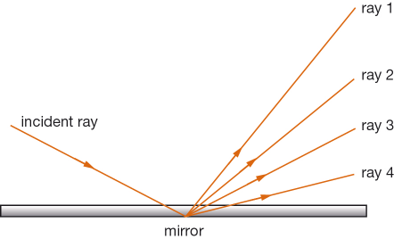

  - Ray 1
  - Ray 2
  - Ray 3
  - Ray 4
- The electromagnetic radiation visible to the human eye is?
  - X-rays
  - Infrared
  - Visible light
  - Radio waves

- This table below shows the approximate speed of sound in various materials and at different temperatures. By looking at this data you could conclude that:

Material | Speed of sound (m/s)
Air (at 0°C) | 331
Air (at 18°C) | 342
Water | 1440
Wood | 4500
Steel | 5100
Glass | 5200

  - sound travels faster through substances that are more dense
  - sound travels at the same speed through all materials
  - sound travels faster at cooler temperatures
  - sound cannot pass through glass

- Which form of radiation has the shortest wavelength?
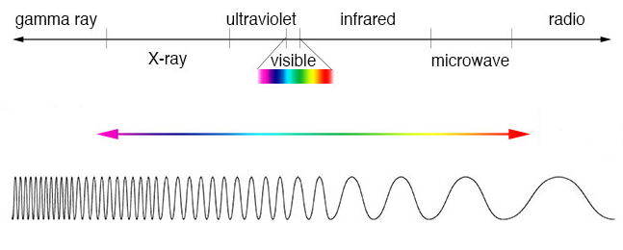
  - Gamma Rays
  - X-rays
  - Infrared
  - Ultraviolet

- Frequency x wavelength = ?
  - Ultraviolet radiation
  - Speed of money
  - Speed of sound
  - Radio waves

- Which of the following waves has the highest frequency and lowest amplitude?

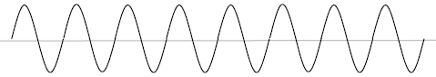

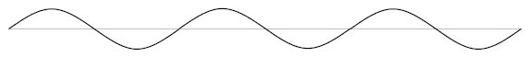

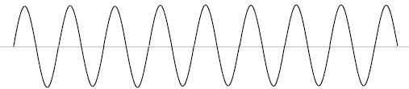

- Visible light is part of the electromagnetic spectrum. Which of these is not also part of the electromagnetic spectrum?
  - gamma waves.
  - radio waves.
  - ultraviolet waves.
  - water waves.

- Light bends as it passes from one transparent substance into another. This is called
  - reflection.
  - refraction.
  - diffusion.
  - transmission.

- In a mirror image, or plane mirror reflection, objects appear
  - upside down.
  - upside down and back to front.
  - back to front.
  - closer.

- A Green object is seen as the colour green because
  - It absorbs all visible light and reflects the green spectrum
  - It refracts green light
  - It absorbs all green light and reflects the rest of the visible spectrum
  - It reflects a rainbow of colours

- The part of the ear that provide us with our sense of balance is the:
- semi-circular canals
- Eustachian tube
- oval window
- pinna

The next three questions refer to the diagram of the eye below.
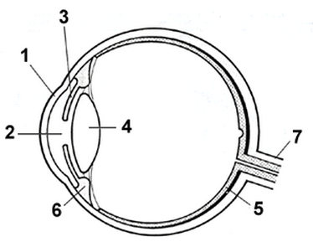

17. The part of the eye that is labelled 1 is called the
  - lens
  - retina
  - cornea
  - sclera

18. The part of the eye that is labelled 2 is called the
  - lens
  - iris
  - pupil
  - cornea

19. The function of the iris is to
a) focus light onto the retina.
- adjust the amount of light entering the eye.
- control the amount of fluid inside the eye.
- protect the eye and stop it from drying out.

- Which of the following diagrams represents a convex lens?
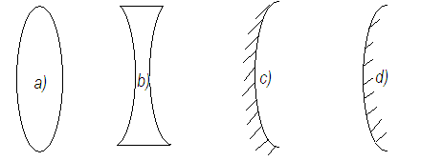

2020 Physics 2 Light and Sound Test

Multiple Choice Answer Sheet

Name: ___________________ Year: 9

Multiple Choice – 20 questions.
Circle your choice. If you change your mind, scrub your choice out and circle the one you want. If it is messy, clearly write your choice next to question.

1. A B C D
2. A B C D
3. A B C D
4. A B C D
5. A B C D
6. A B C D
7. A B C D
8. A B C D
9. A B C D
10. A B C D
11. A B C D
12. A B C D
13. A B C D
14. A B C D
15. A B C D
16. A B C D
17. A B C D
18. A B C D
19. A B C D
20. A B C D

Correct answers: ______ / 20 questions

SECTION 2: WRITTEN
Write your answers on the lined paper provided.

- Circle the correct values to complete this sentence: (2)
Sound waves travel through air at approximately 340 / 300 000 000 metres per second, whereas light (also called electromagnetic) waves travel through a vacuum at approximately 340 / 300 000 000 metres per second.
- Study the following diagram of a wave, then answer the questions below: (5)
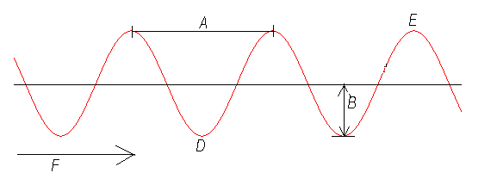
Which letter corresponds to each of the following?

- direction of energy transfer
- crest
- trough
- amplitude
- wavelength

- Tom and Sally buy tickets for the House of Horrors at the Royal Show. Inside, the only lights are red and green. Tom is wearing blue jeans and a red jumper. Sally is wearing a yellow dress and black shoes. (4)
Describe how their clothes would appear using words such as “no colour’ or type of colour (red, blue, yellow…) inside the House of Horrors in:
a red light
b green light
 | Blue  jeans | Red  jumper | Yellow  dress | Black  shoes
a) red light
b) green light

- The diagram below shows a light ray travelling through air to the interface between the air and a glass block. (4)
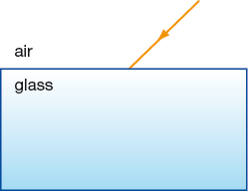

- On the diagram, draw the normal and a possible path for the ray in the glass.
- If the glass block were now to be replaced with denser glass of greater refractive index, what difference this would make to the path of the ray?
____________________________________________________________________________________________________________________________________________________________________________________________________________________________________

- a) Ivan makes a low sound of 55 Hz while talking to his friends. Calculate the wavelength of this sound. (2)

________________________________________________________________________________________________________________________________________________________________________________________________________________________________________________________________________________________________________________

b) A radio station broadcasts radio waves that have a wavelength of 298 cm. What is its broadcast frequency? (3)
________________________________________________________________________________________________________________________________________________________________________________________________________________________________________________________________________________________________________________
Formula you might need:
v = f x λ

END OF TEST (OUT OF 40 MARKS)

